D Section D — AI-Augmented Learning
STEP 1 · BUILD WITH AI Use an AI tool of your choice (ChatGPT, Claude, GitHub Copilot, etc.) to help you write a C program that: Accepts exactly 10 integers from the user using a loop and stores them in an array. Finds and displays the maximum value, minimum value, and arithmetic mean (displayed as a float with 2 decimal places). Sorts the array in ascending order using any sorting method and displays the sorted list. Prints whether the mean is closer to the minimum, closer to the maximum, or exactly midway between them.
STEP 2 · TEST & DEBUG (WITHOUT AI) Then, working without AI, test the code using boundary inputs: (a) all 10 values identical, (b) a mix of positive and negative integers, and (c) a list where the mean falls exactly between min and max. Find at least one bug, edge-case failure, or improvement in the AI's solution and fix it yourself.
SUBMIT
All 3 items required 1 The exact prompt(s) you gave the AI tool. 2 The AI's original code and your corrected version (submit both as separate .c files). 3 A 3–4 line note explaining what you changed and why the AI's original version needed the correction.
- Exact Prompt Given to AI
Write a C program that:
- Accepts exactly 10 integers from the user using a loop and stores them in an array.
- Finds and displays the maximum value, minimum value, and arithmetic mean (as a float with 2 decimal places).
- Sorts the array in ascending order and displays the sorted array.
- Prints whether the mean is closer to the minimum value, closer to the maximum value, or exactly midway between them.
- Use arrays, loops, and basic C programming concepts.
- AI Original Code
#include <stdio.h>

int main()
{
int arr[10];
int i, j, temp;
int min, max, sum = 0;
float mean;

printf("Enter 10 integers:\n");

for(i = 0; i < 10; i++)
{
scanf("%d", &arr[i]);
sum += arr[i];
}

min = max = arr[0];

for(i = 1; i < 10; i++)
{
if(arr[i] < min)
min = arr[i];

if(arr[i] > max)
max = arr[i];
}

mean = sum / 10;

for(i = 0; i < 9; i++)
{
for(j = i + 1; j < 10; j++)
{
if(arr[i] > arr[j])
{
temp = arr[i];
arr[i] = arr[j];
arr[j] = temp;
}
}
}

printf("\nMinimum = %d\n", min);
printf("Maximum = %d\n", max);
printf("Mean = %.2f\n", mean);

printf("Sorted Array: ");
for(i = 0; i < 10; i++)
{
printf("%d ", arr[i]);
}

if((mean - min) < (max - mean))
printf("\nMean is closer to Minimum\n");
else if((mean - min) > (max - mean))
printf("\nMean is closer to Maximum\n");
else
printf("\nMean is exactly midway\n");

return 0;
}

Output:
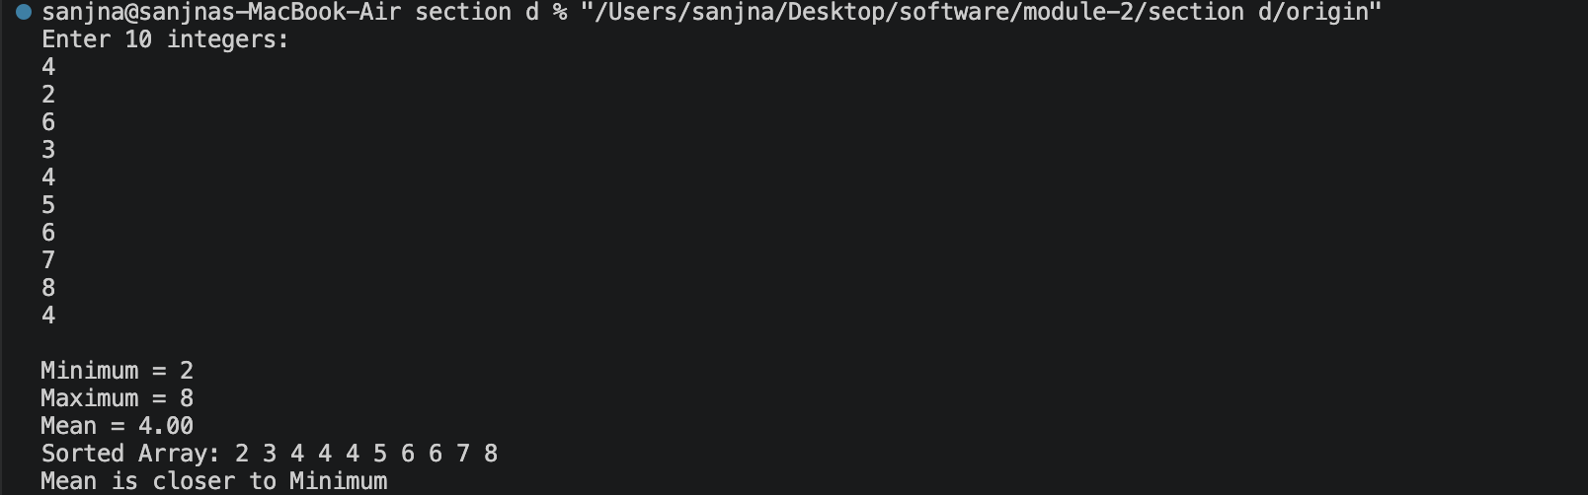
- Corrected Code
#include <stdio.h>

int main()
{
int arr[10];
int i, j, temp;
int min, max;
int sum = 0;
float mean;

printf("Enter 10 integers:\n");

for(i = 0; i < 10; i++)
{
scanf("%d", &arr[i]);
sum += arr[i];
}

min = max = arr[0];

for(i = 1; i < 10; i++)
{
if(arr[i] < min)
min = arr[i];

if(arr[i] > max)
max = arr[i];
}

mean = (float)sum / 10;

for(i = 0; i < 9; i++)
{
for(j = i + 1; j < 10; j++)
{
if(arr[i] > arr[j])
{
temp = arr[i];
arr[i] = arr[j];
arr[j] = temp;
}
}
}

printf("\nMinimum = %d\n", min);
printf("Maximum = %d\n", max);
printf("Mean = %.2f\n", mean);

printf("Sorted Array: ");
for(i = 0; i < 10; i++)
{
printf("%d ", arr[i]);
}

float distMin = mean - min;
float distMax = max - mean;

if(distMin < distMax)
printf("\nMean is closer to Minimum\n");
else if(distMin > distMax)
printf("\nMean is closer to Maximum\n");
else
printf("\nMean is exactly midway between Minimum and Maximum\n");

return 0;
}

Output:
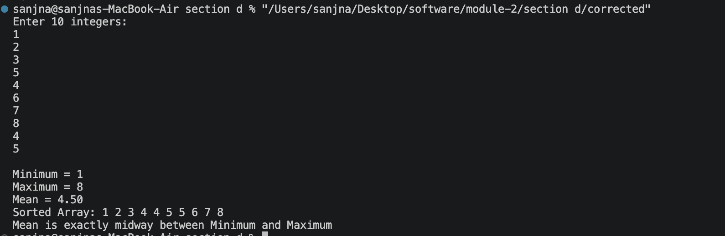

- 3–4 Line Note
- While testing the AI-generated program, I found that the mean calculation used integer division:
- mean = sum / 10;
- This caused incorrect results when the average contained decimal values. I corrected it to:
- mean = (float)sum / 10;
- so that the arithmetic mean is calculated accurately and displayed with the required two decimal places. The correction improves the accuracy of the program, especially for mixed positive and negative inputs.

